# CS 255 Business Requirements Document Template

Complete this template by replacing the bracketed text with the relevant information.

This template lays out all the different sections that you need to complete for Project One. Each section has guiding questions to prompt your thinking. These questions are meant to guide your initial responses to each area. You are encouraged to go beyond these questions using what you have learned in your readings. You will need to continually reference the interview transcript as you work to make sure that you are addressing your client’s needs. There is no required length for the final document. Instead, the goal is to complete each section based on your client’s needs.

**Tip:** You should respond in a bulleted list for each section. This will make your thoughts easier to reference when you move into the design phase for Project Two. One starter bullet has been provided for you in each section, but you will need to add more.

## System Components and Design

### Purpose

*What is the purpose of this project? Who is the client and what do they want their system to be able to do?*

* The purpose of this project is to develop a comprehensive, user-friendly system that helps students prepare for and pass their driving tests.
* The system will allow students to take online practice exams that simulate the real DMV test experience.
* Students will also be able to schedule on-the-road driving lessons with certified instructors based on real-time availability.
* The client, DriverPass, wants a solution that combines test preparation, practical driving training, progress tracking, and scheduling in one platform.

### System Background

*What does DriverPass want the system to do? What is the problem they want to fix? What are the different components needed for this system?*

* DriverPass identified a critical issue in the driver education process: more than 65% of students fail their driving tests because they rely only on static test questions from past exams.
* There is currently a lack of interactive tools and coordinated driving lesson systems available to students.
* DriverPass wants a system that provides both online, interactive exam preparation and the ability to coordinate in-person driving lessons with instructors.
* The new system will support multiple user roles: students, instructors, and administrators.
* Key components include: an exam module, a scheduling system, performance tracking tools, secure user account management, and administrative controls.

### Objectives and Goals

*What should this system be able to do when it is completed? What measurable tasks need to be included in the system design to achieve this?*

* Provide online practice tests in the style of an interactive, actual DMV test.
* Allow driving lessons to be booked with local instructors by students.
* Track student progress, provide performance reports, and give individualized feedback.
* Allow DriverPass staff to have business, schedules, and customers managed.
* Make instructor availability, scheduling lessons, and cancellations easier.
* Allow online payment and secure user management.

## Requirements

### Nonfunctional Requirements

*In this section, you will detail the different nonfunctional requirements for the DriverPass system. You will need to think about the different things that the system needs to function properly.*

#### Performance Requirements

*What environments (web-based, application, etc.) does this system need to run in? How fast should the system run? How often should the system be updated?*

* The system must be web-based and mobile-friendly to ensure wide accessibility.
* Practice tests must load in 2 seconds or less during normal usage.
* The system should be updated regularly
* System uptime should be maintained at 99.9% or higher.

#### Platform Constraints

*What platforms (Windows, Unix, etc.) should the system run on? Does the back end require any tools, such as a database, to support this application?*

* The application must run on all major platforms including Windows, macOS, Android, and iOS.
* Database management will rely on a relational DBMS like PostgreSQL or MySQL.
* Frontend must support Chrome, Firefox, Safari, and Edge browsers

#### Accuracy and Precision

*How will you distinguish between different users?* *Is the input case-sensitive? When should the system inform the admin of a problem?*

* Each user will have a unique ID, and user sessions will be validated with secure tokens.
* User input will be case-sensitive where appropriate (e.g., passwords).
* The system will notify the admin of abnormal activities, failed logins, and scheduling errors.

#### Adaptability

*Can you make changes to the user (add/remove/modify) without changing code? How will the system adapt to platform updates? What type of access does the IT admin need?*

* Administrators should be able to add or delete users from the system without requiring programming changes.
* For a simple process adding additional features (such as video tutorials or new DMV formats), the system design should be flexible.
* An admin dashboard should be available to IT professionals so they can dynamically manage users, content, and system configurations.
* Future integration with DMV databases or APIs should be supported by the system.

#### Security

*What is required for the user to log in? How can you secure the connection or the data exchange between the client and the server? What should happen to the account if there is a “brute force” hacking attempt? What happens if the user forgets their password?*

* Users required to enter a valid password and email address to log in.
* It is necessary to save passwords using secure encryption, such as bcrypt.
* For instructor and administrator logins, two-factor authentication (2FA) must be taken into account.
* HTTPS/SSL encryption is required for all user-server communications.
* An alert will be sent to the user's email, and the account will be temporarily locked after five unsuccessful attempts to log in.
* Through email verification, users will be able to safely reset their passwords if they forget them.

### Functional Requirements

*Using the information from the scenario, think about the different functions the system needs to provide. Each of your bullets should start with “The system shall . . .” For example, one functional requirement might be, “The system shall validate user credentials when logging in.”*

* The system shall allow students to register and manage their accounts.
* The system shall allow students to take interactive practice tests.
* The system shall store and display practice test scores.
* The system shall allow students to book, reschedule, and cancel driving lessons.
* The system shall provide instructors with access to their schedule and assigned students.
* The system shall allow instructors to record student progress after lessons.
* The system shall enable admins to manage users, test content, and schedules.
* The system shall send automated notifications and reminders via email/SMS.
* The system shall process payments and refunds securely.

### User Interface

*What are the needs of the interface? Who are the different users for this interface? What will each user need to be able to do through the interface? How will the user interact with the interface (mobile, browser, etc.)?*

* The interface must be available through desktop and mobile browsers.
* Students must be able to access: Take tests, View performance, and Schedule lessons
* Instructors must have: Calendar interface to manage schedules and Student profiles with history of progress
* Admins must have: Dashboard with full CRUD authority over users and schedules and Access to analytics, feedback, and payment systems
* The interface must be intuitive, responsive, and ADA-compliant.

### Assumptions

*What things were not specifically addressed in your design above? What assumptions are you making in your design about the users or the technology they have?*

* Internet access should be reliable for users.
* DriverPass has certified and investigated the backgrounds of all instructors.
* Payments will be processed through a third-party processor, such as PayPal or Stripe.
* Users of the system will need to register with accurate contact details.

### Limitations

*Any system you build will naturally have limitations. What limitations do you see in your system design? What limitations do you have as far as resources, time, budget, or technology?*

* The system does not initially interface with official DMV testing or scheduling systems.
* DriverPass services are only available in areas with certified instructors.
* Advanced features like live chat or AI-based feedback may not be able to be included at launch due to budgetary constraints.
* Support staff availability may be restricted to business hours.
* Performance issues may occur during high user loads without additional scaling.

### Gantt Chart

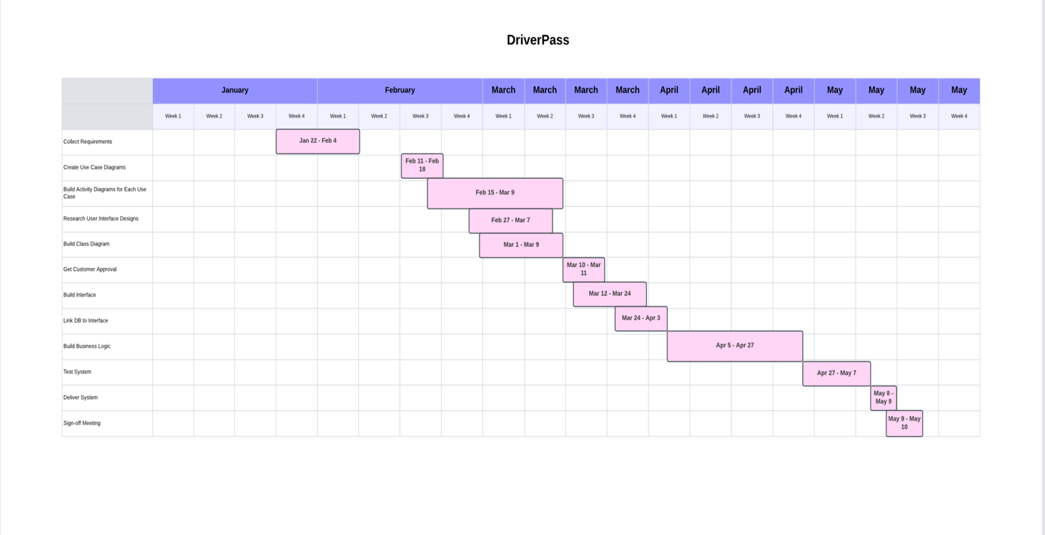*Please include a screenshot of the GANTT chart that you created with Lucidchart. Be sure to check that it meets the plan described by the characters in the interview.*